COGS 17 A03 Week 2 Problem Set

1) Match the planar Views using the following terms: coronal plane, horizontal plane, and sagittal plane.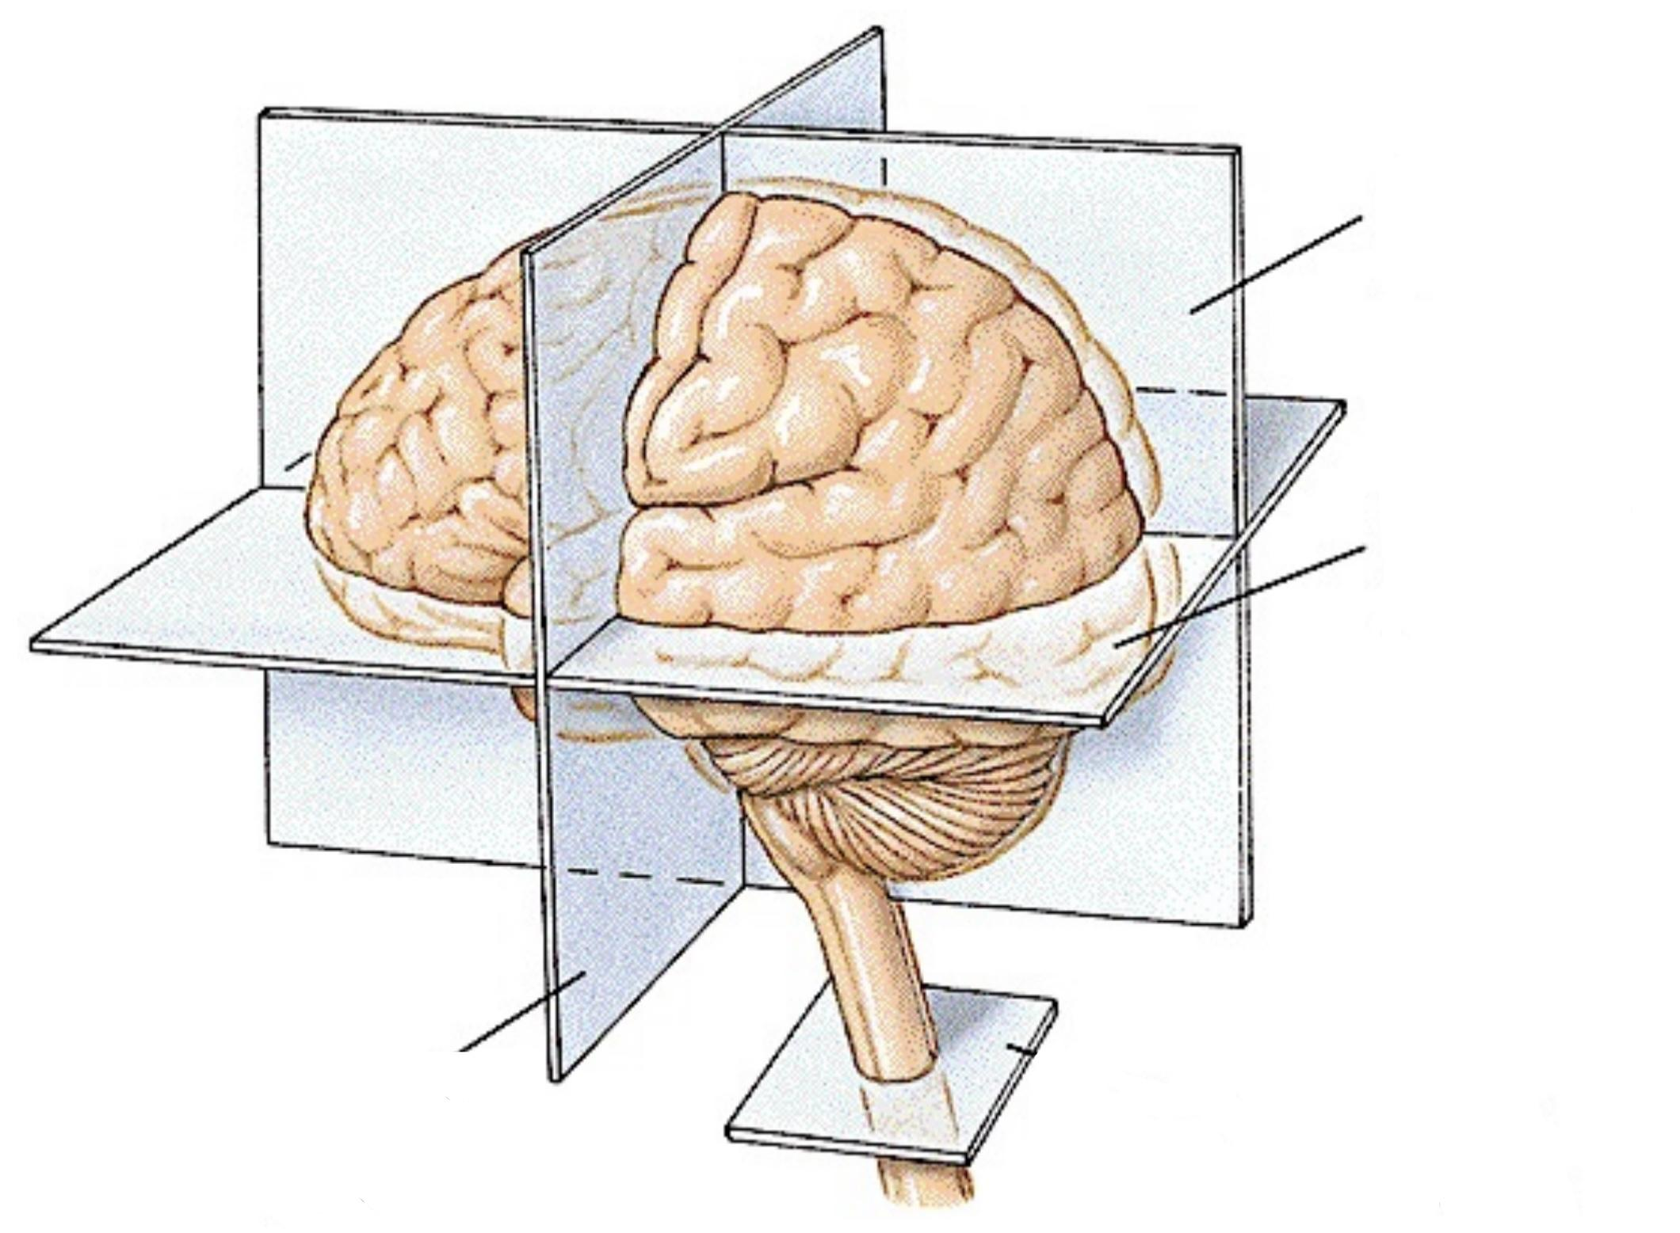

2) A tumor involving the left side of the brain may cause paralysis of the right leg. Is this an example of an ipsilateral connection or a contralateral connection?

3) The central nervous system is sheathed in the 3-layered meninges, what are the three layers? Please indicate in the graph.

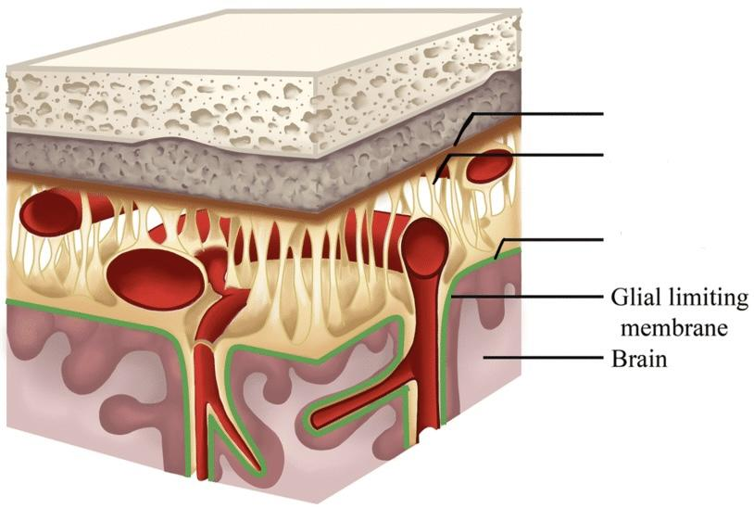

4) How many ventricles are there in the brain? Where are they located? What is the main function of ventricles?

5) What are the main functions of the blood-brain barrier? What particles can passively cross the barrier?

6) What are the major functions of Medulla, Pons, and cerebellum?

7) What makes up the midbrain and what are the functions of each of those parts?

8) What are the two divisions of the forebrain?

9) What makes up the diencephalon and what are the functions of those parts?

10) What makes up the telencephalon and what are the functions of those parts?

11) Name the four lobes of the brain. What are the main functions of each lobe?

